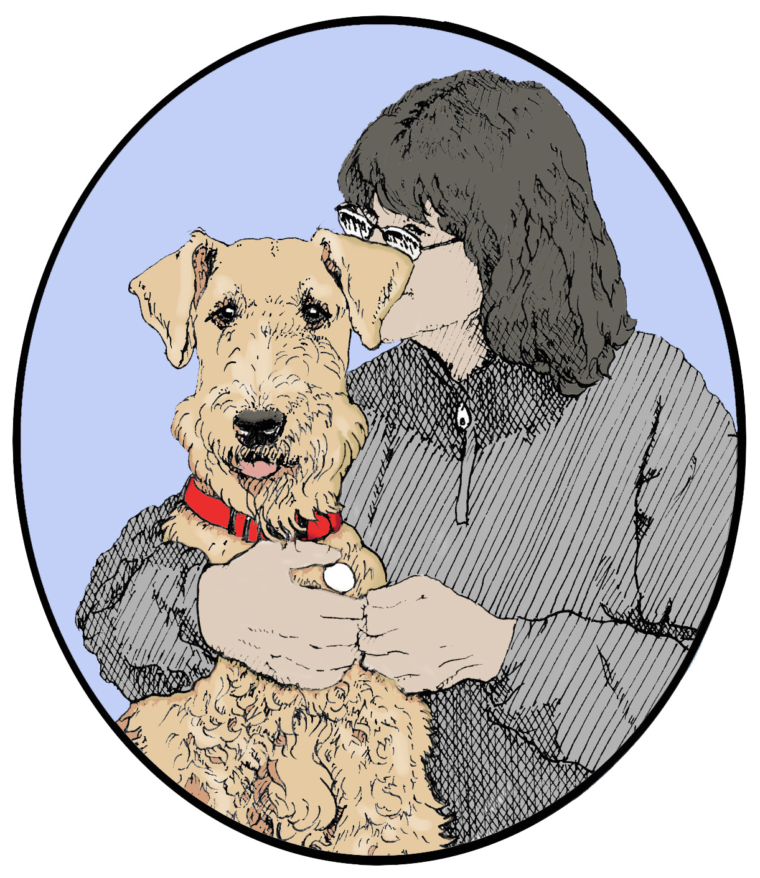
Starting Over Airedale Rescue, Inc.
1721 Peavy Road • Howell, MI 48843 • 517-546-8303 • www.soar-airedale-rescue.com

